Greater Kansas City Employee Benefit Professionals Association
Certificate of Attendance

Name ________________________________________________________

Program Date: June 15, 2023
Topic: 2023 Annual Benefits Seminar

Presenters:
Alex Lanning, CBIZ
Daniel Meylan, Zelis
Lacey Bowen and Tammie McCoy, CBIZ
Greg Cain, Principal Financial Group
Rory Kane Akers, J.D., Lockton Companies

This program, Activity 23-SP2HY, has been awarded 5.0 PDCs (Professional Development Credits) for SHRM-CP℠ or SHRM-SCP℠.

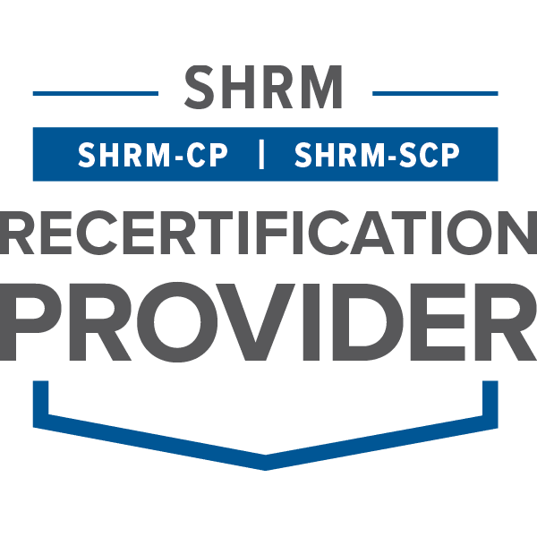

The Greater Kansas City Employee Benefit Professionals Association is recognized by SHRM to offer Professional Development Credits (PDCs). For more information about certification or recertification, please visit the SHRM website at www.shrm.org.

